Tony Nguyen

Dr. Shawn Bowers

CPSC 324 01

12 February 2024

Homework 1

1. **Step 1**
2. *Question a*

* IAM (Cloud Identity and Access Management) is used to inspect and modify these roles and permissions.
* Three types of IAM basic roles
  + Roles/Viewers
    - Read-only actions
    - Do not affect state
    - E.g., viewing but not modifying the existing resources or data
  + Roles/Editor
    - All viewer permission
    - Also permit actions that modify state
  + Roles/Owner
    - All editor and viewer permissions
    - Also allows managing roles and permissions for a project and setting up billing for a project

1. *Question b*

* Storage Admin
  + Grant full control of objects and buckets
  + Only applied to an individual bucket and objects within it
* Storage Object Admin
  + Grant full control of objects
  + Including listing, creating, viewing, and deleting
  + Note that only objects are granted access, not the entire bucket
* Storage Folder Admin
  + In Beta version
  + Grant full control over folders and objects
  + Including listing, creating, viewing, and deleting
  + Higher privilege than Storage Object Admin but still lower than Storage Admin

1. *Question c*

* Cloud Translation API
  + Integrate text translation into a website or application
  + $45/hour use, which is quite expensive
  + I realize that, based on my personal experience, Google’s translation service is getting smarter and more reliable. The wording and semantics sound more natural.
* Cloud Vision API
  + Integrate the Google Vision feature
  + Able to label images, faces, logos, and landmarks, OCR, and more into applications
  + Potentially easier to use compared to Keras OCR as this API leverages a wide range of pre-trained data
  + 3.5 cents per count
* Vertex AI API
  + Powerful tool to train custom machine learning models with minimal machine learning expertise and efforts
  + Leverage Gemini, a generative AI model, to power the API
  + Has the ability to recognize and understand essentially any inputs

1. **Step 2**

1. **Step 3**

* Commands
  + In
    - gcloud init
  + Create a new bucket
    - Buckets are the basic containers that hold data
    - gcloud storage buckets create gs://cnguyen4-cpsc324-hw1-bucket1 --uniform-bucket-level-access
  + Copy an image from a location on your local machine to a bucket
    - gcloud storage cp Downloads/kitten.png gs://cnguyen4-cpsc324-hw1-bucket1
  + Download an object from your bucket
    - gcloud storage cp gs://cnguyen4-cpsc324-hw1-bucket1/kitten.png Downloads/kitten.png
    - Note that this is similar to uploading a resource locally to Google Cloud
  + Copy an object to a folder in the bucket
    - gcloud storage cp gs://cnguyen4-cpsc324-hw1-bucket1/kitten.png gs://cnguyen4-cpsc324-hw1-bucket1/folder1/kitten3.png
    - Note the same structure
  + List operation
    - gcloud storage ls gs://cnguyen4-cpsc324-hw1-bucket1/
    - gcloud storage ls gs://cnguyen4-cpsc324-hw1-bucket1/ --long
    - Similar to the Linux command line
    - Note that the *--long* tag returns detailed image information
  + Make the objects publicly available
    - gcloud storage buckets add-iam-policy-binding gs://cnguyen4-cpsc324-hw1-bucket1/ --member=allUsers --role=roles/storage.objectViewer
    - gcloud storage buckets remove-iam-policy-binding gs://cnguyen4-cpsc324-hw1-bucket1/ --member=allUsers --role=roles/storage.objectViewer
    - Note that adding and removing have similar structures
    - If we want to add and/or remove a specific user, set *--member=user:jane@gmail.com*. Similar structure above
  + Delete an object
    - gcloud storage rm gs://cnguyen4-cpsc324-hw1-bucket1/kitten.png
  + Clean up
    - gcloud storage rm gs://cnguyen4-cpsc324-hw1-bucket1/ --recursive
* Screenshot before deleting

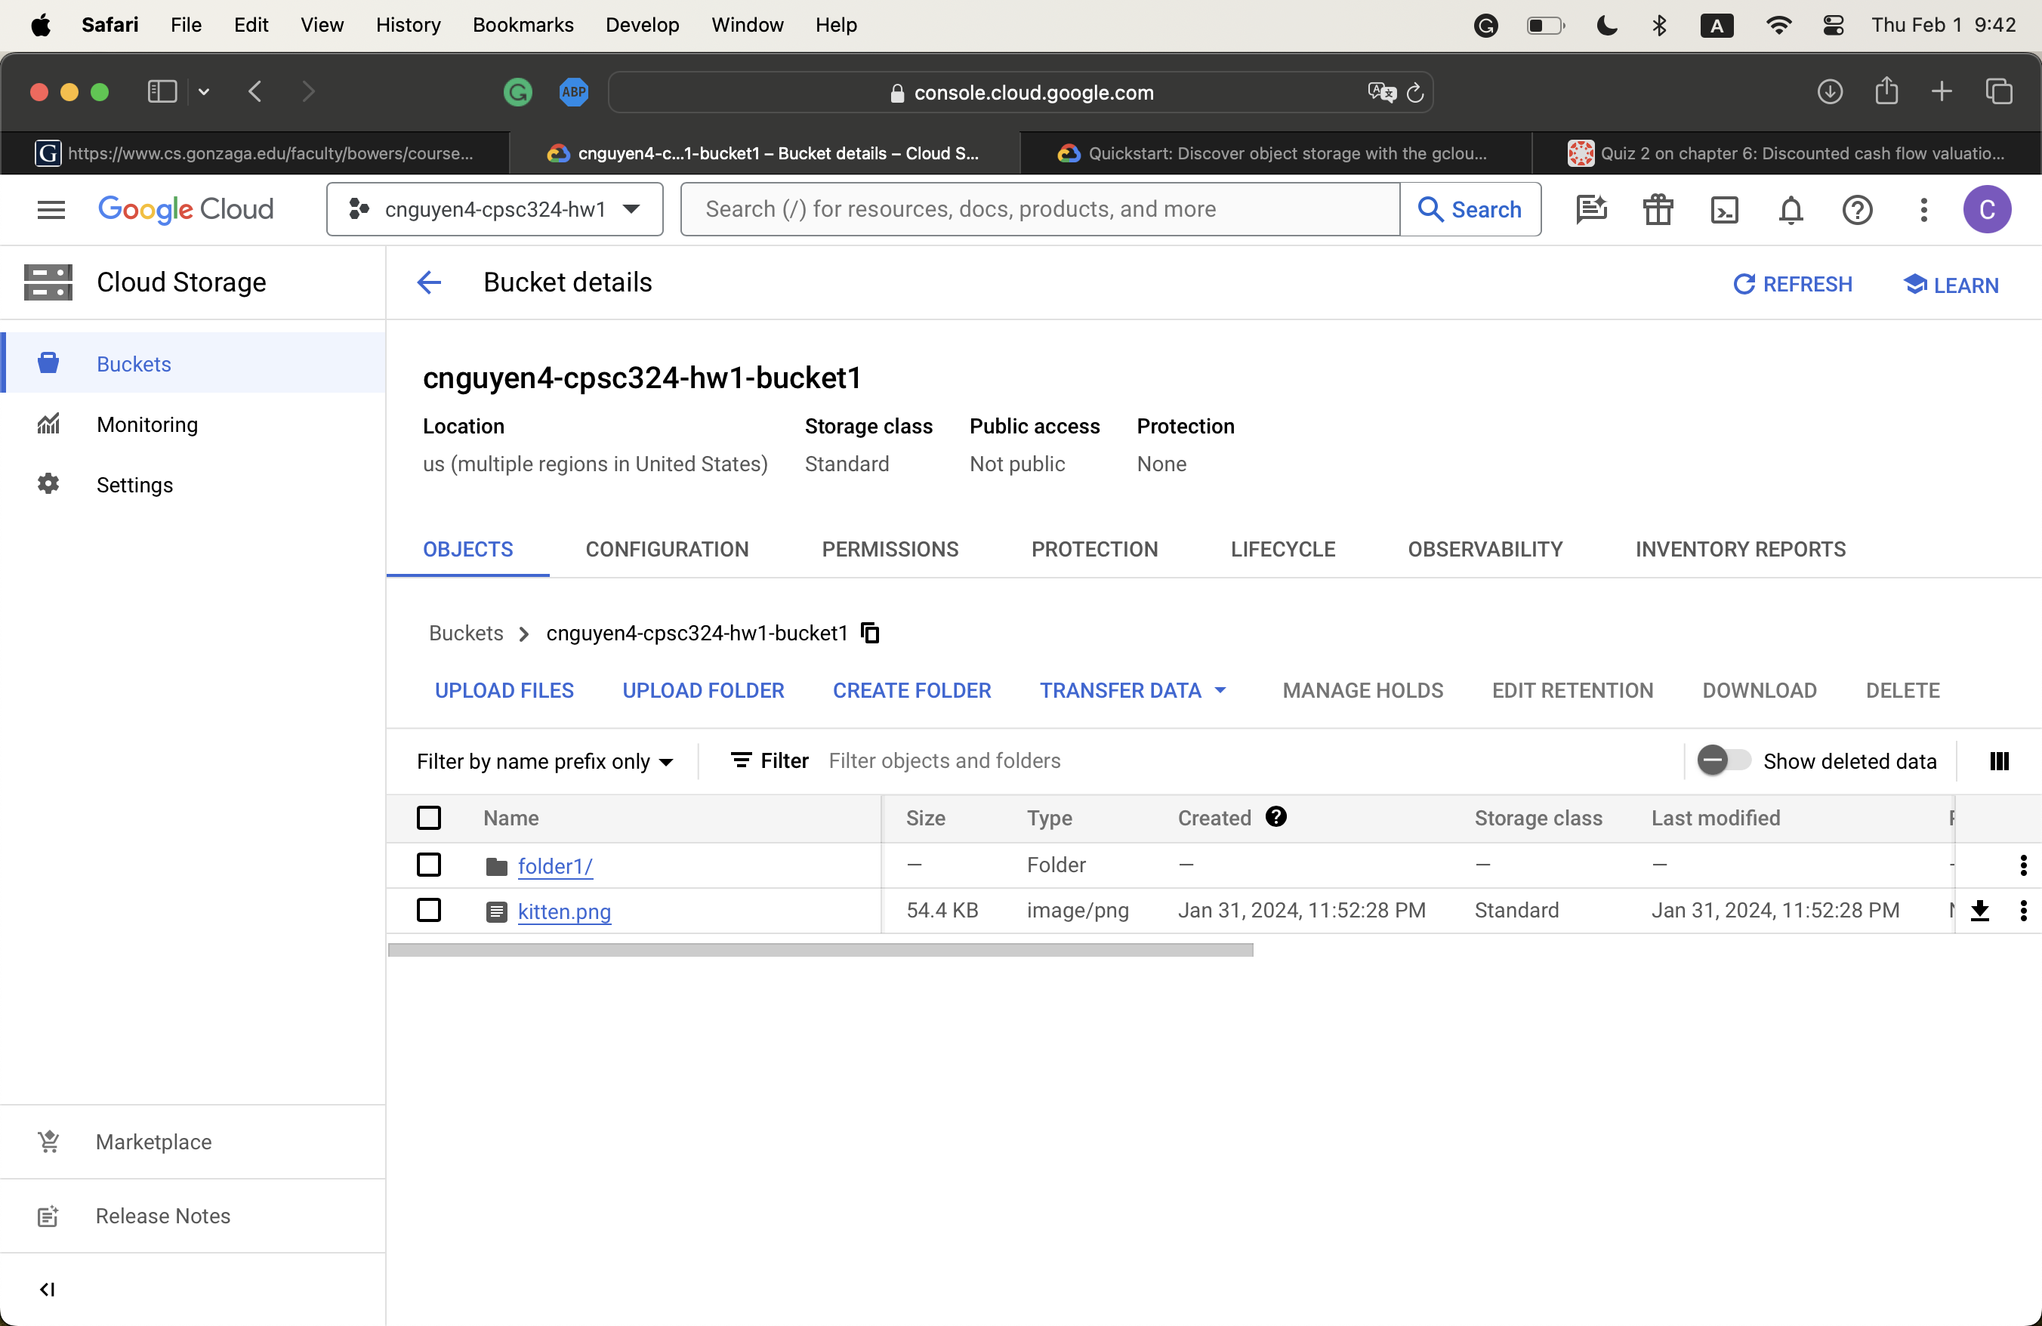

1. **Step 4**

* <https://storage.cloud.google.com/cnguyen4-cpsc324-hw1-bucket1/kitten.png?authuser=2>.

1. **Step 5**

* Ephemeral mode means that files created during a given session are deleted after it ends
* Using Cloud Shell to run a Python Script
  + A screenshot of a computer

    Description automatically generated
* Using Cloud Shell to upload a file
  + A screenshot of a computer

    Description automatically generated
* Using Cloud Shell to download a file
  + cloudshell download *file_name*
  + 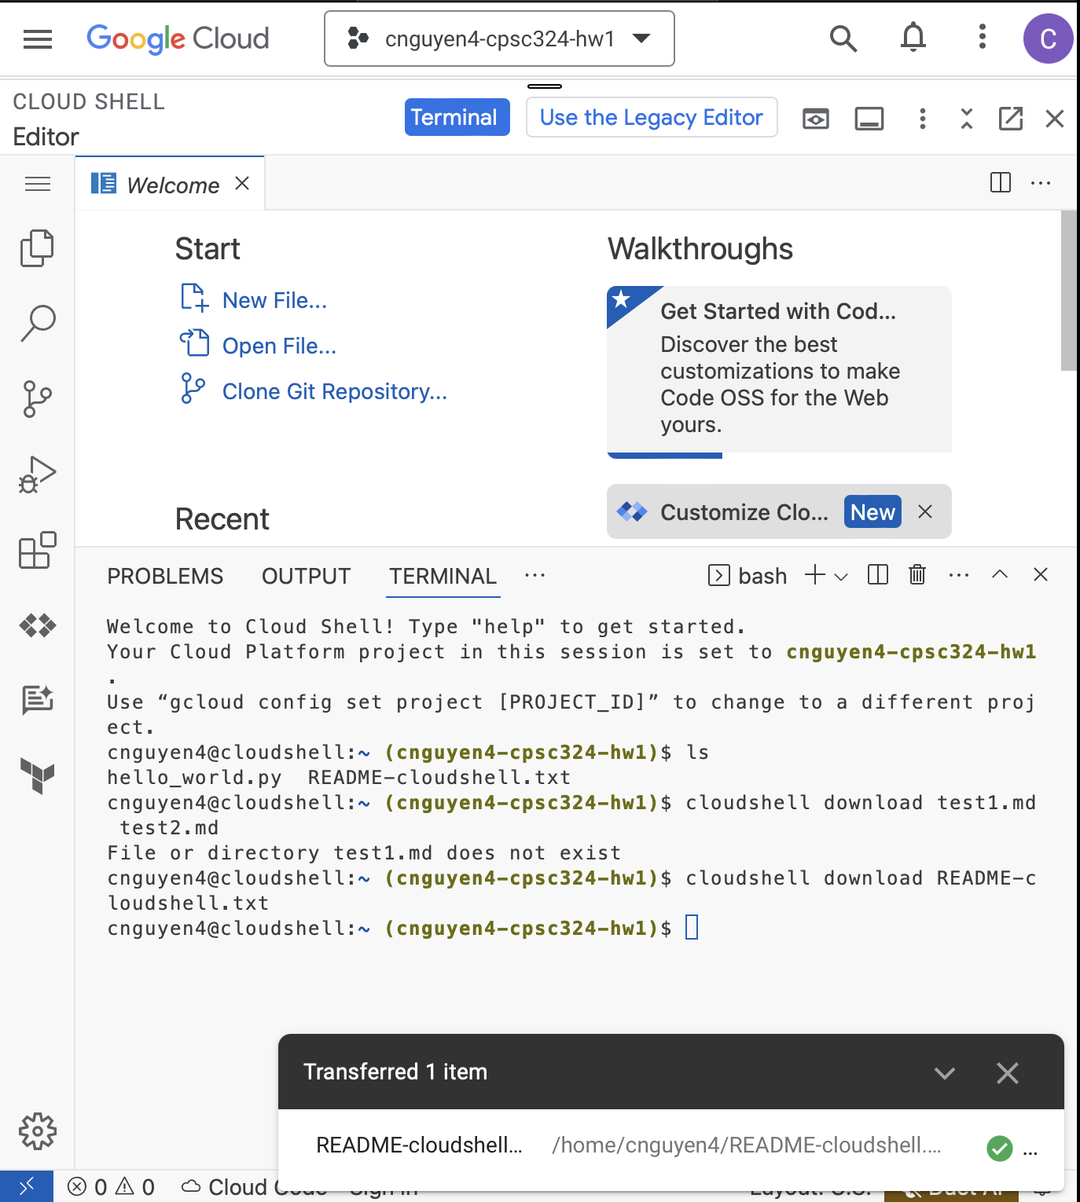
* Using a local terminal to transfer/download files from Cloud Shell to the Local environment
  + gcloud cloud-shell scp cloudshell:/home/cnguyen4/kitten.png localhost:kitten.png
  + Note that this command should be run within the target director=]
  + Tag cloudshell and localhost can be interchanged to depict the side of transfer
  + A black screen with white text

    Description automatically generated

1. **Step 6**

* A screenshot of a computer screen

  Description automatically generated

1. **Step 7**

* Download and unzip the file

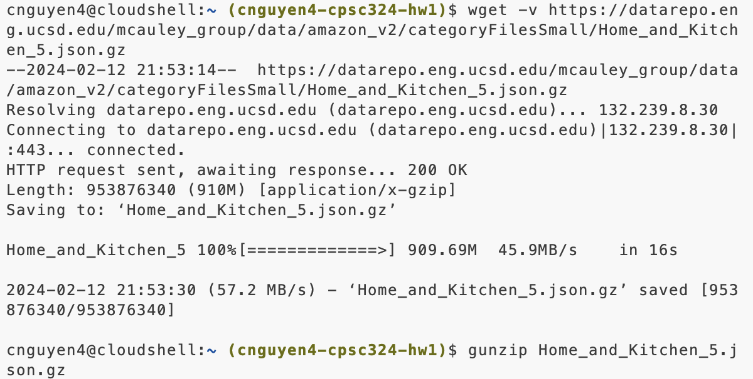

* Create a new bucket and upload it

1. **Step 8**

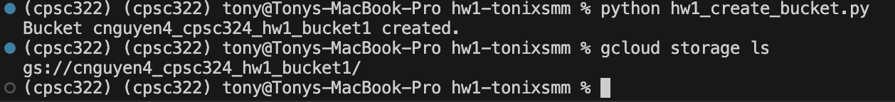

1. Step 9



